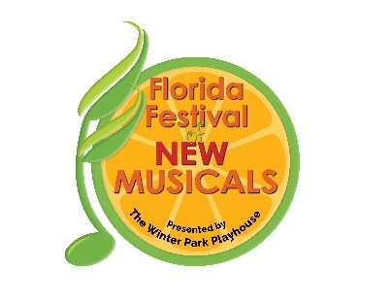

**2024 FLORIDA FESTIVAL OF NEW MUSICALS**

**APPLICATION**

**DATE: _________________**

**APPLICANT INFORMATION**

**Name of Applicant: ______________________________________________________________________**

**Street Address: _________________________________________________________________________**

**City/State: _______________________________Country: _________________ Zip Code: ___________**

**Applicant Phone: _____________________ Applicant Email: __________________________________**

**Other Writers’ Emails: ___________________________________________________________________**

**SHOW INFORMATION**

**Title of Musical: _________________________________________________________________________**

**Book by: ______________________________________City/State/Country: _______________________**

**Lyrics by: _____________________________________City/State/Country: _______________________**

**Music by: _____________________________________ City/State/Country: _______________________**

**# of Roles:** ­_____ **Can reading be done with 10 or less if artists read multiple parts?** **YES ____ NO____**

**Synopsis: Please attach a brief description of the show, no longer than a half page.**

**Is the musical completely original? YES _____ NO _____**

(If YES, please submit a signed letter from the creators that the musical is original.)

**Does the musical contain any copyrighted material? YES _____ NO _____**

(If YES, please submit a signed letter from the authors and underlying rights representatives stating the rights have been secured.)

**Does the musical contain material that is now in the public domain? YES_____ NO_____**

(If YES, please submit a letter stating when the material entered the public domain.)

**\*\*\*NOTE: There is no fee to apply or to participate in the Festival. Please refer to the application guidelines for information on submission requirements.**

*The Winter Park Playhouse is a professional musical theatre, a registered 501(c) (3) non-profit charitable organization and is proudly affiliated with Actors' Equity Association and the*

*National Alliance for Musical Theatre.*

**711 Orange Ave. Winter Park, FL 32789 * 407-645-0145 * winterparkplayhouse.org**